**FOUNDATIONS OF AGILE AND AGILE FRAMEWORKS**

Meet Your Instructor

Welcome

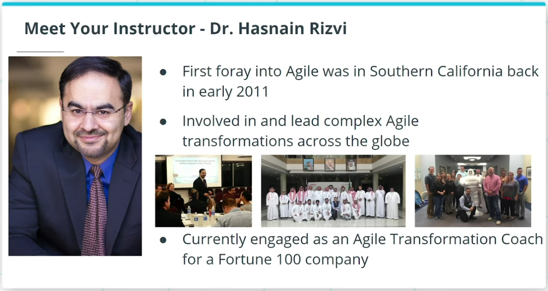

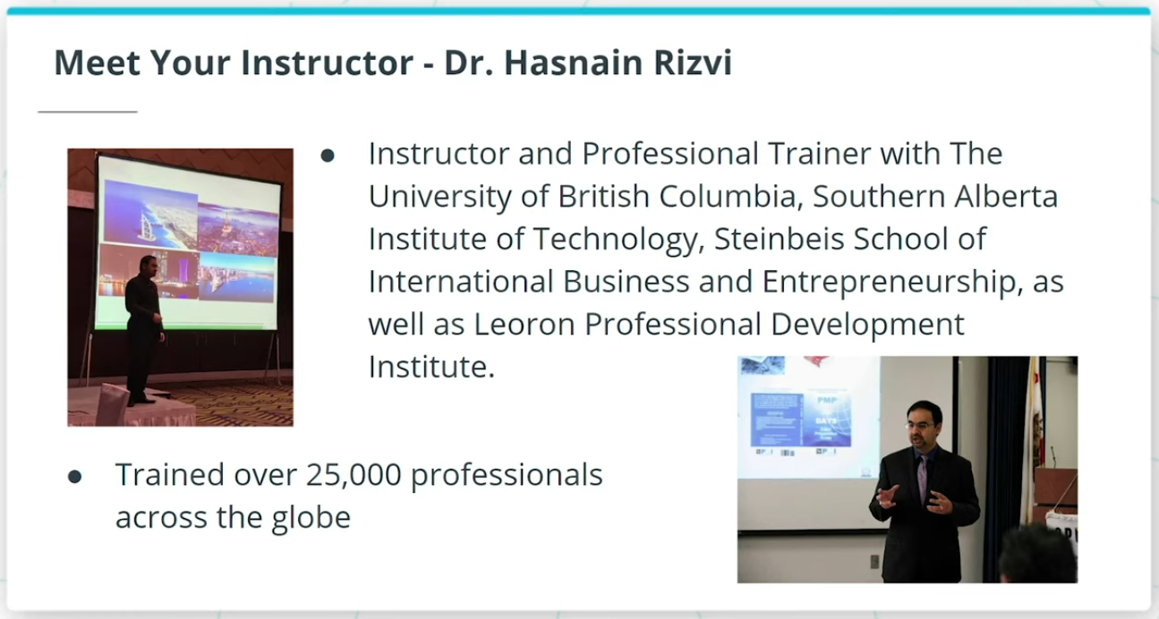

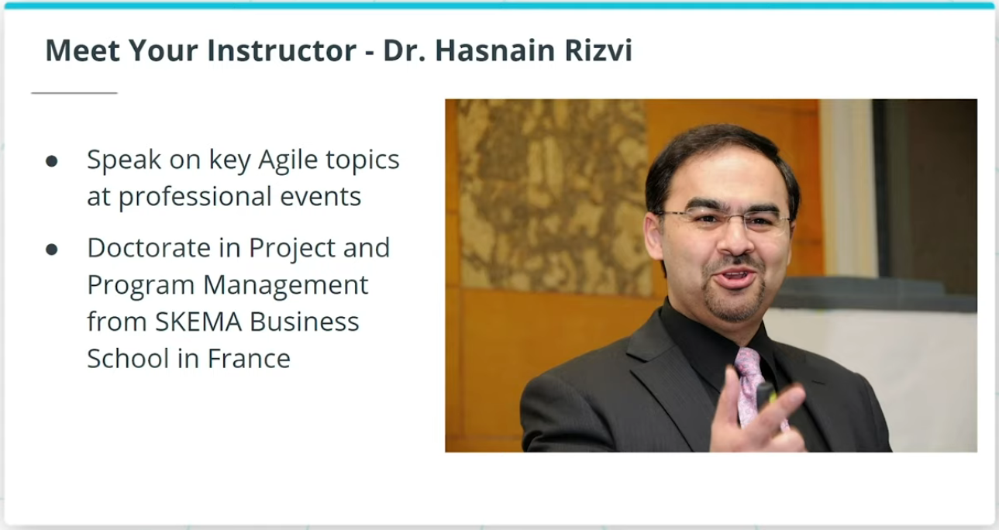

• Agile Coach with over 20 years of hands-on Business Analysis, Project Management, and Agile Transformation experience

• Doctorate in Project and Program Management from SKEMA Business School, France

• Adjunct instructor with multiple renowned universities

• Mentored, trained, and coached over 25,000 participants globally

• Advisor to leading-edge start-ups in California and Texas

• Regularly presenter at international professional conferences and events

# Course Outline

## What We Will Cover In This Course

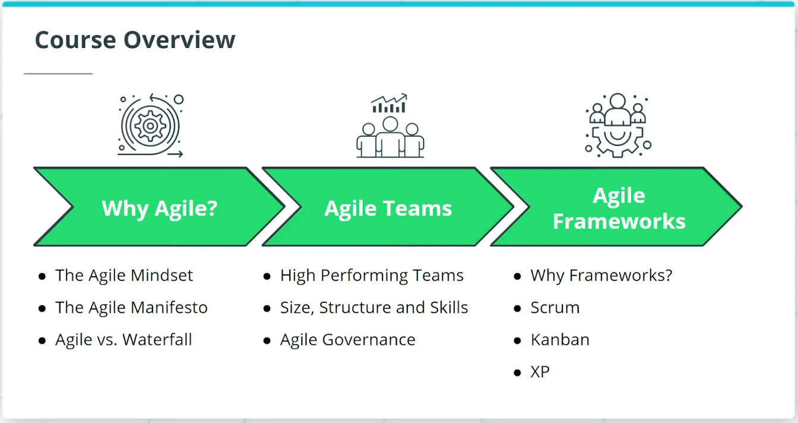

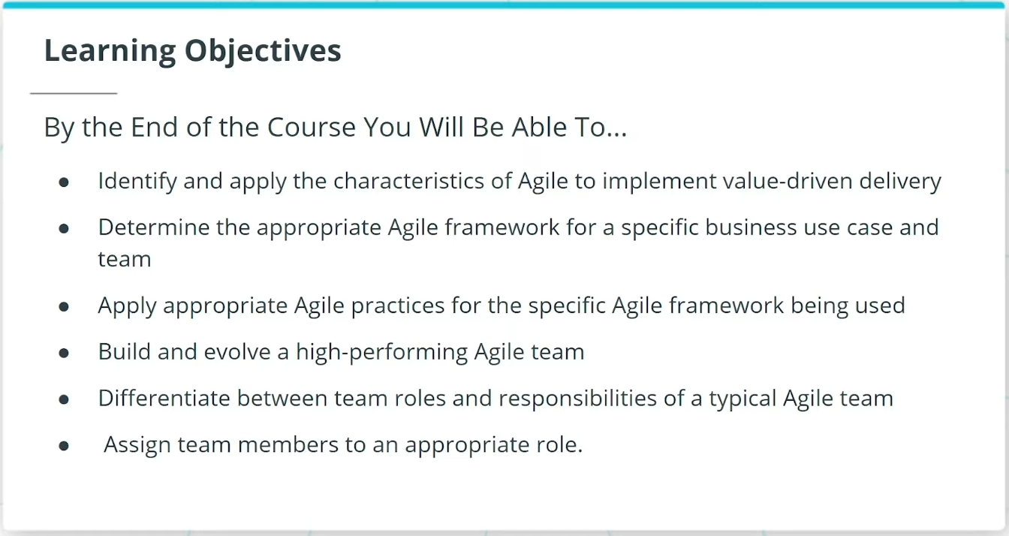

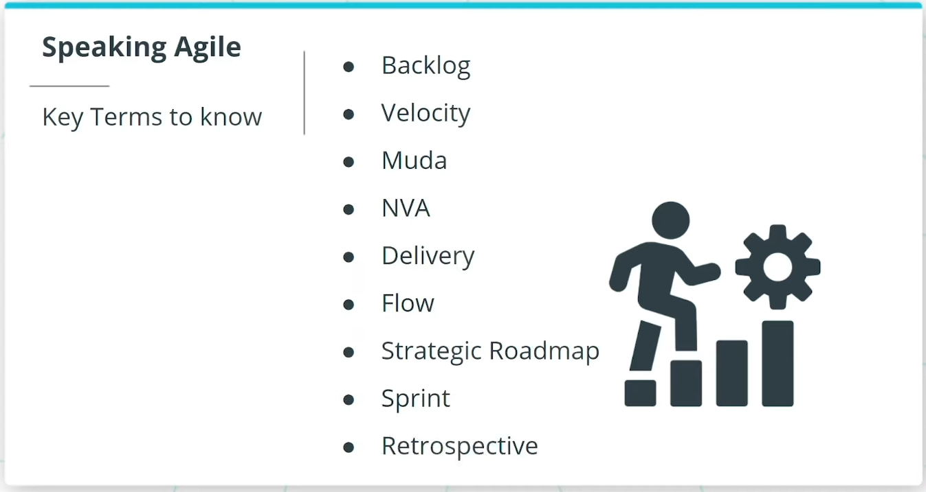

### **Why Agile?**

We will start off by discussing why Agile has taken today’s digital economy by storm. We will focus on:

* The Agile Mindset and how it sets the tone for ‘Being’ Agile versus just ‘Doing’ Agile.
* The Agile Manifesto, and how it is seen as the foundational set of 4 Paired Core Values and 12 Principles that sets the foundation for all Agile Frameworks.
* We will wrap up The Why Agile lesson with an important discussion on Agile versus Waterfall Approaches. We will then build upon the foundational principles of Agile and take a deep dive into Agile Teams.

### **Agile Teams**

In this lesson, we will cover the key topics of:

* Key characteristics of high-performing Agile teams.
* The 3 core roles that are generally seen across all Agile frameworks.
* We will also cover the size, structure, and cross-functional skills in an Agile team.
* We will conclude this lesson with a discussion on Agile Governance.

### **Agile Frameworks**

The last lesson will cover Agile Frameworks.

* We will begin with an overview of Agile Frameworks in general and how each of them leverages The Agile Manifesto’s 4 Paired Core Values and 12 Principles. We will see how Agile Frameworks are the practical vehicle for enabling Agile in successful teams.
* After this, we will cover 3 of the more popular Agile Frameworks being utilized across all industries.
* We will first discuss the Scrum Framework.
* We will then move on to Kanban, one of the more lightweight frameworks.
* Finally, we will cover Extreme Programming (XP). We will go over XP’s Core Values and strict Practices.

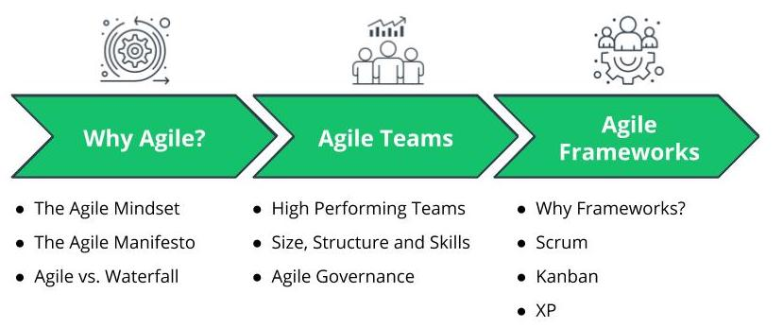

Course Overview

### **By The End of the Course You Will Be Able To...**

* Identify and apply the characteristics of Agile to implement value-driven delivery
* Determine the appropriate Agile framework for a specific business use case and team
* Apply appropriate Agile practices for the specific Agile framework being used
* Build and evolve a high-performing Agile team
* Differentiate between team roles and responsibilities of a typical Agile team
* Assign team members to an appropriate role

### **Prerequisites**

No prior experience is required, but it is recommended that students are comfortable with basic computer skills, such as managing files, using third-party online programs (e.g. Google Slides or Microsoft Word), and navigating the Internet through an online browser.

### **Lesson Outline**

In this introductory lesson, we will cover the following topics:

* The History of Agile
* What Tools Do Agile Teams Use?
* Project Overview

# The History of Agile

## Where Did Agile Come From?

Much like other paradigm shifts in the business world, agile came into existence based on a business need.

Agile emerged organically as a result of a market need to deal with the crisis product development faced in the 1990s. Back in the 1990s, it was taking somewhere in the range of 2-4 years to get a software solution to production from the time it was conceived as a valuable business need. This delay was just not acceptable for enterprise business users. The market had started to evolve and it was beginning to be realized that both the needs and expectations from the business users would not remain static for so long.

A growing number of experts felt that there had to be a better way to build products with a focus on:

* business users, and
* business value.

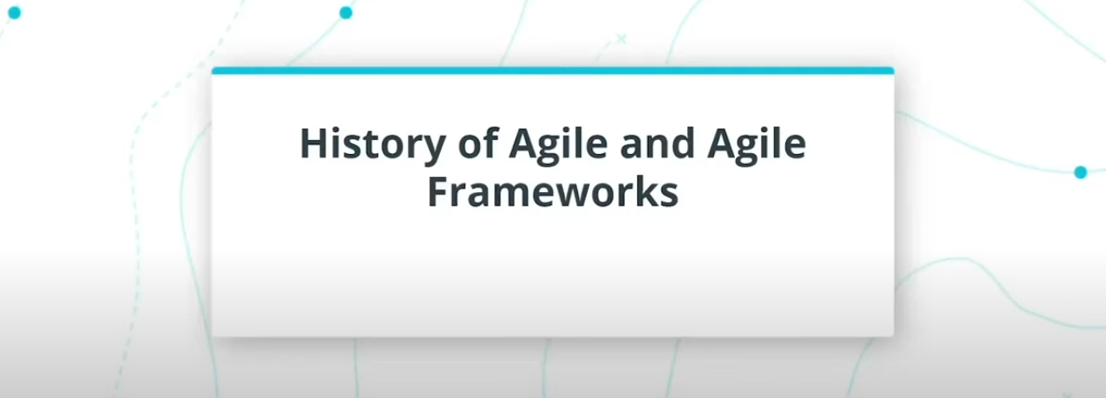

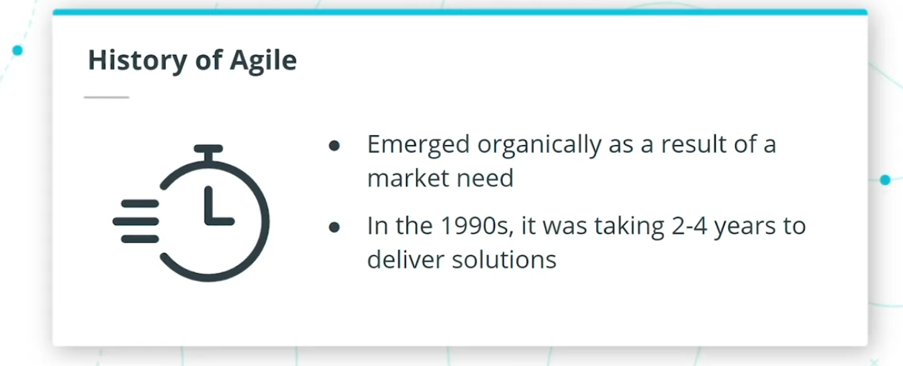

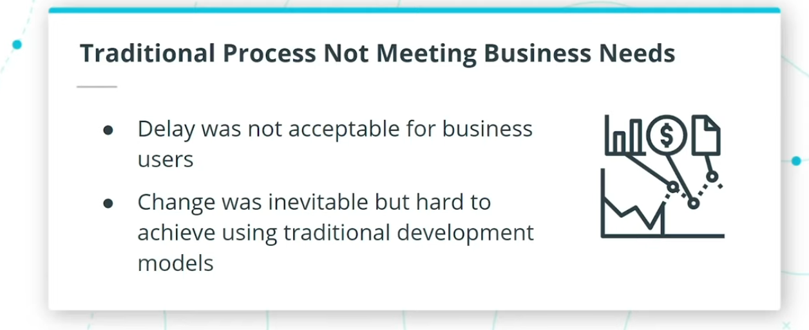

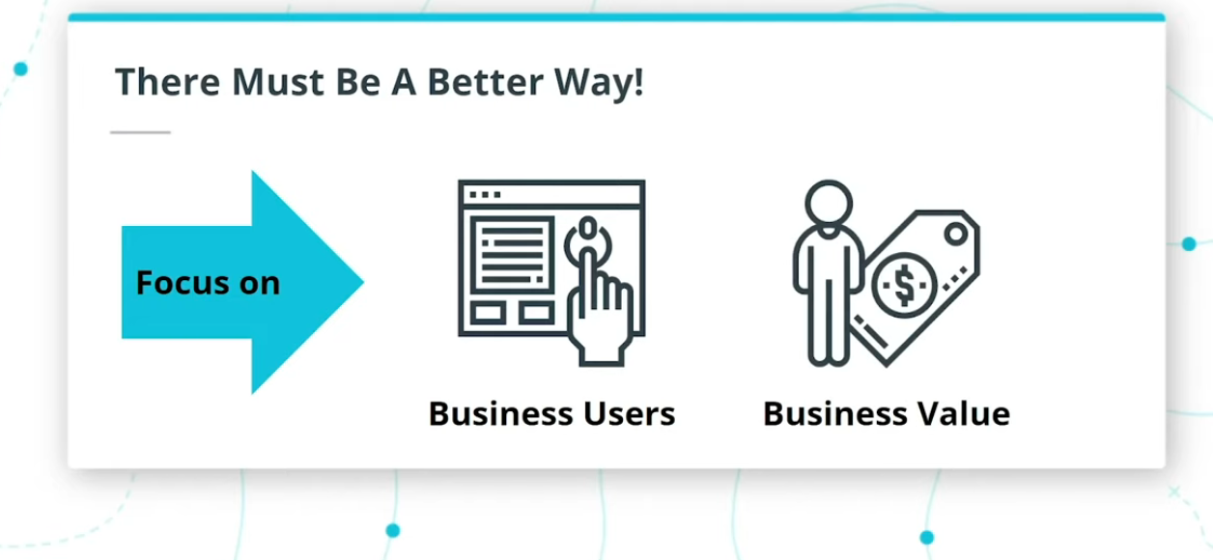

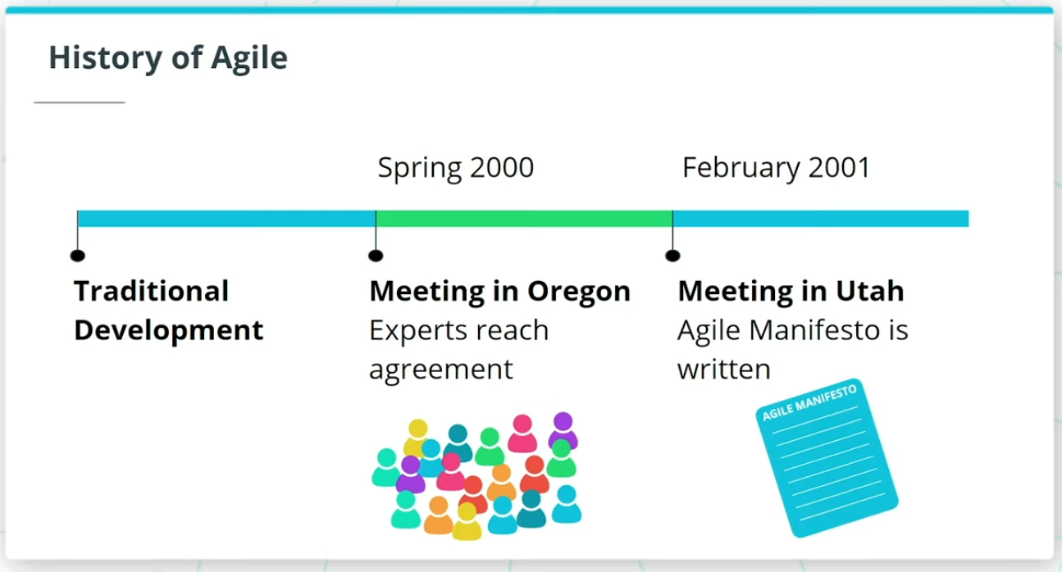

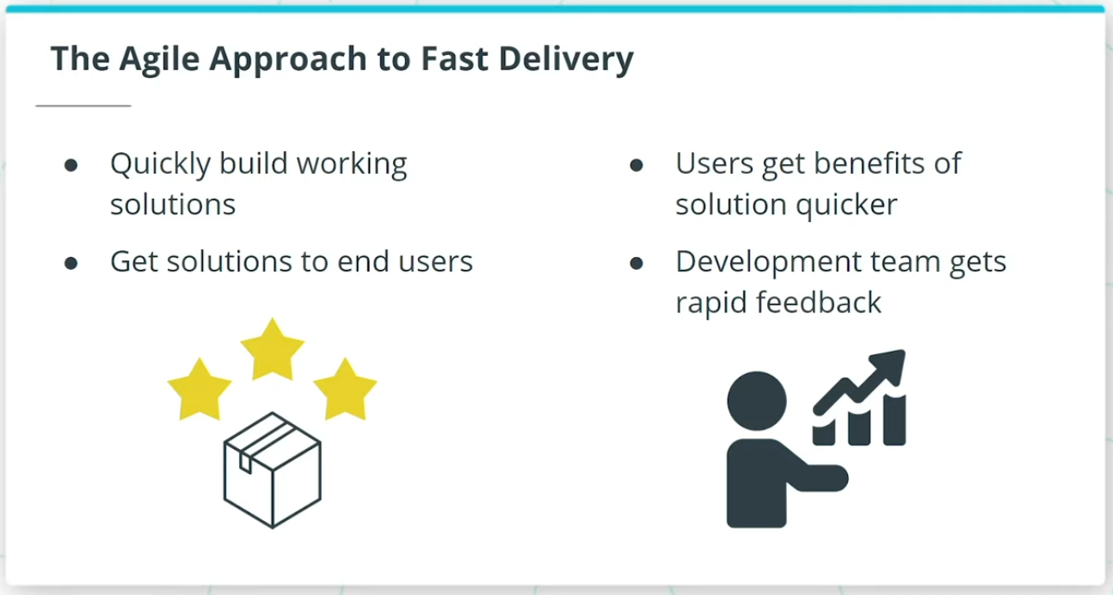

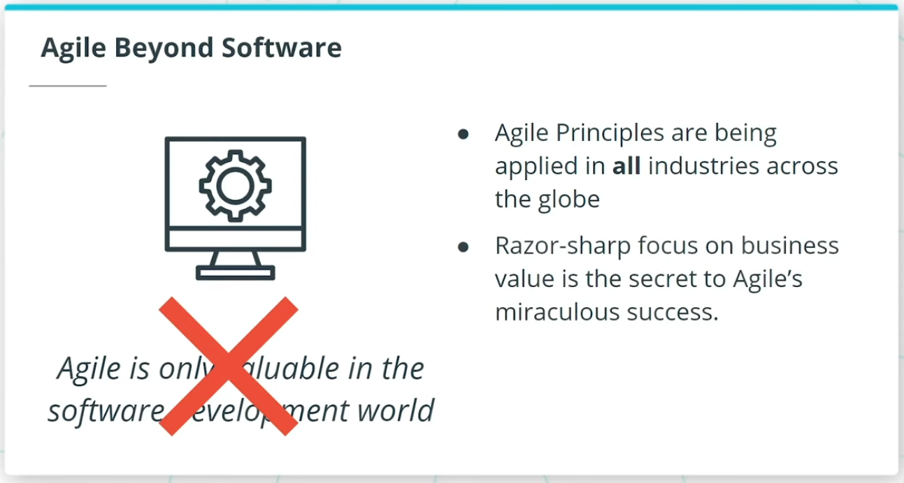

### **History of Agile**

In the Spring of 2000, a group of industry experts gathered in Oregon to come up with some common ground on Agile. This meeting led to a famous gathering in Utah in February 2001 where 17 thought leaders finalized **The Agile Manifesto**. This historic gathering set the foundation for all Agile frameworks.

Since Agile was developed for software development, many think that software is the only place where Agile is valuable. However, today Agile is being applied in all industries across the globe.

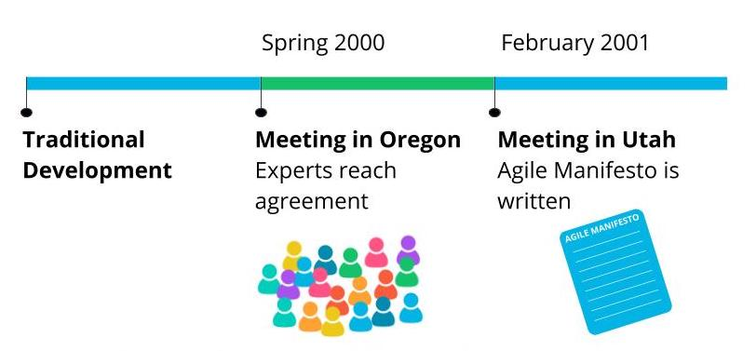

History of Agile

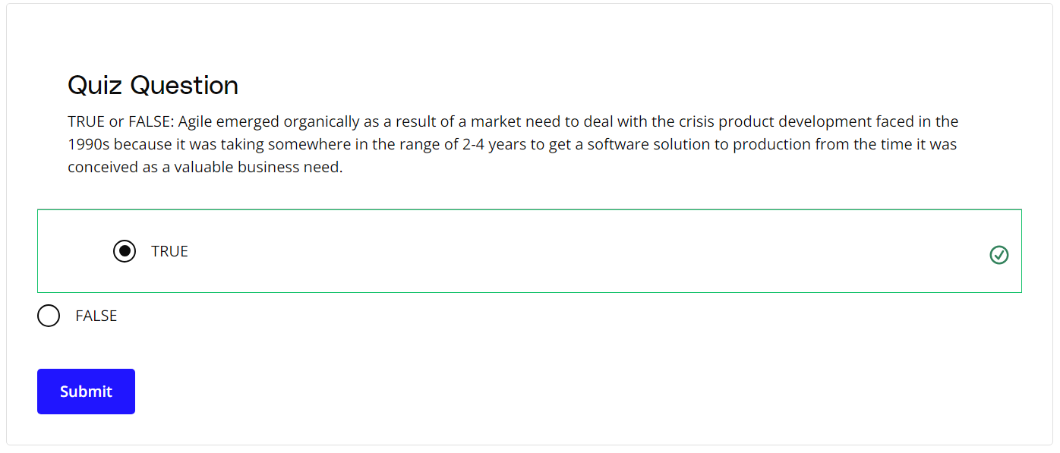

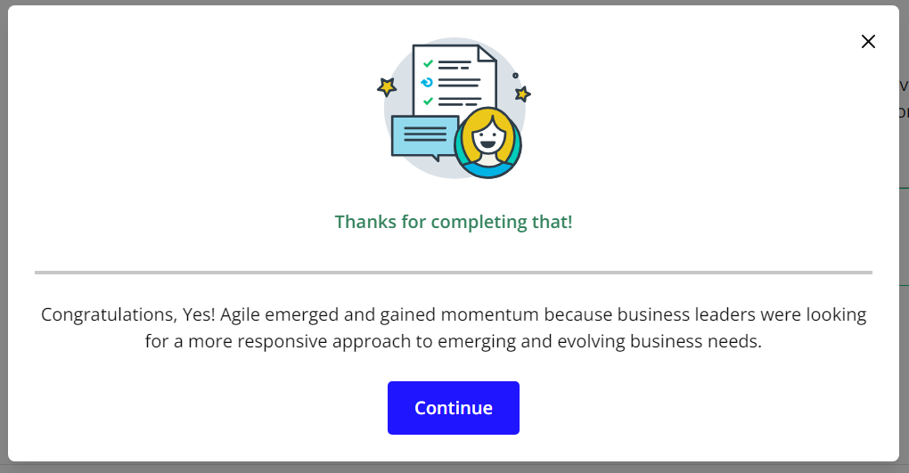

# Agile Tools

## What Tools Do Agile Teams Use?

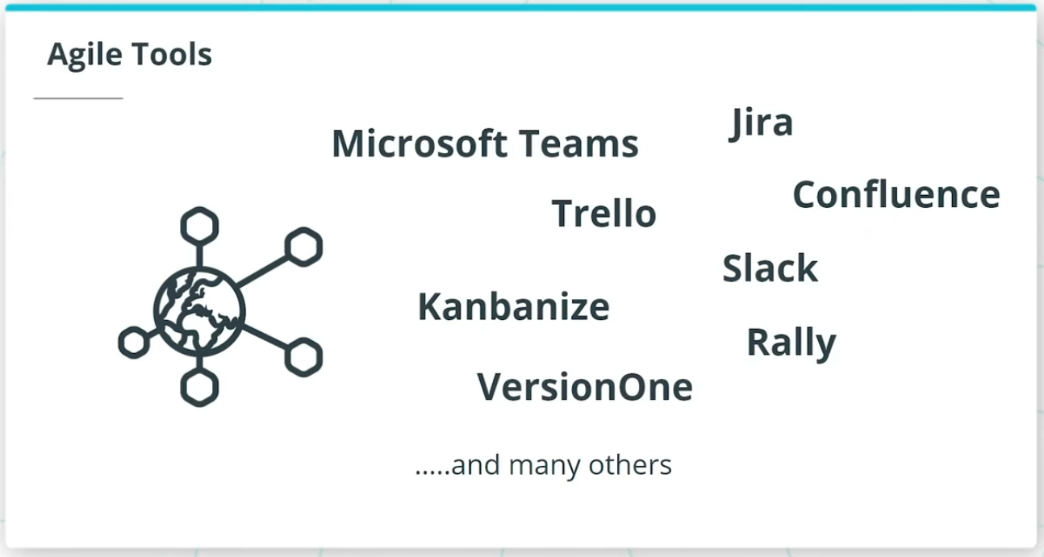

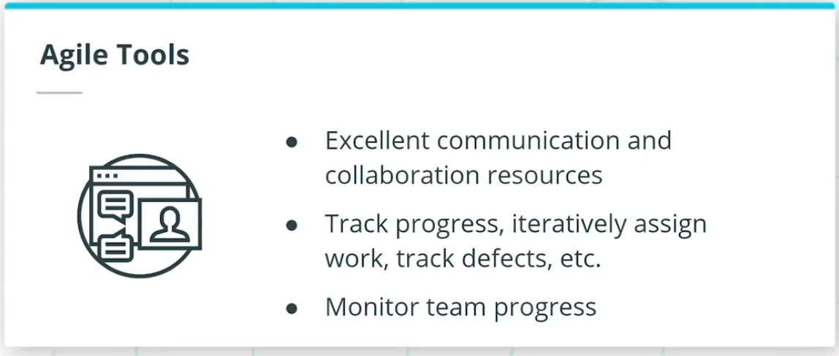

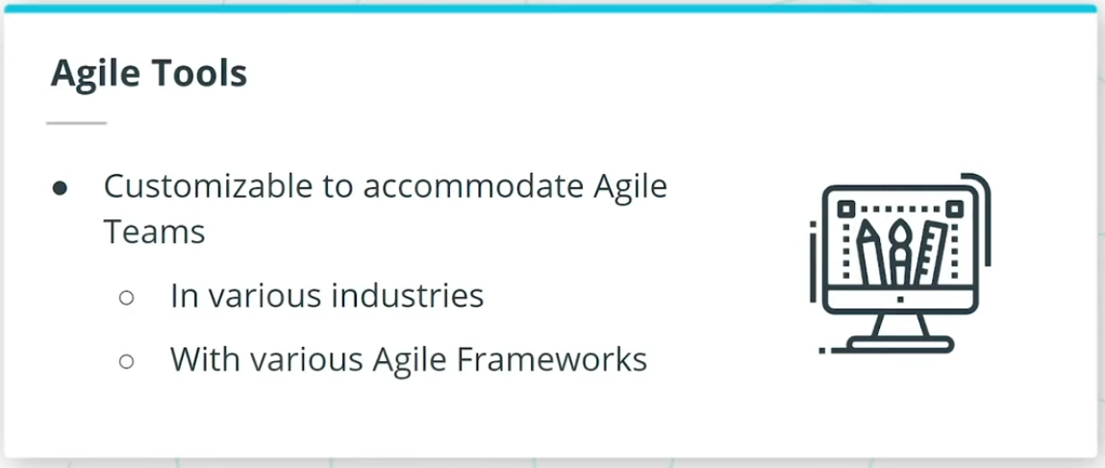

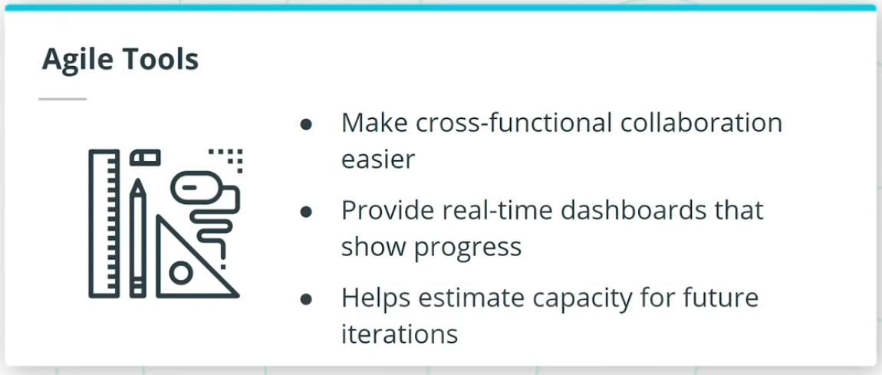

### **Key Points**

Agile tools are excellent communication and collaboration resources. So, for example, they:

* Help monitor the teams’ progress in a transparent and visible manner
* Can be customized to accommodate Agile teams in various industries with different Agile frameworks
* Provide real-time dashboards and reports that show the Agile team’s progress against the product roadmap

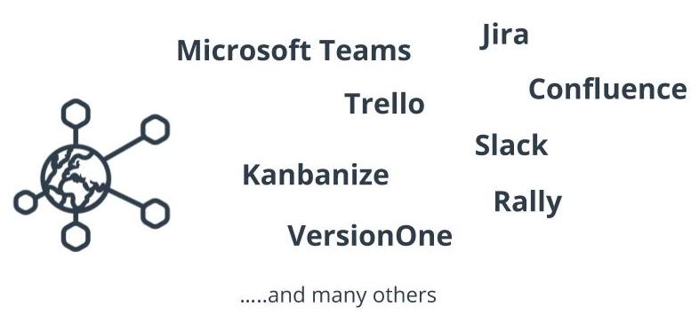

Agile Tools

# Project: WorldVisitz Mobile Application Agile Delivery Launch

## WorldVisitz Agile Transformation

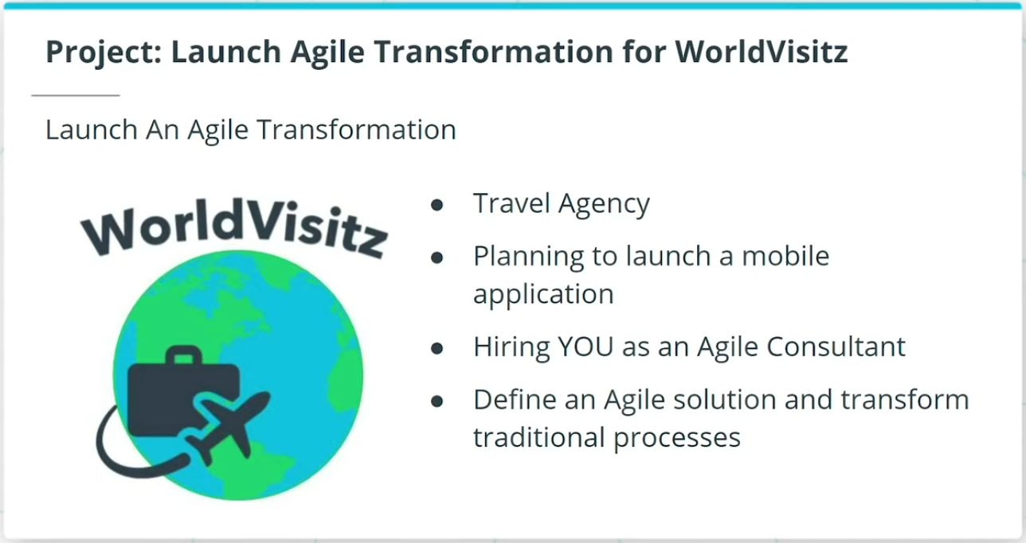

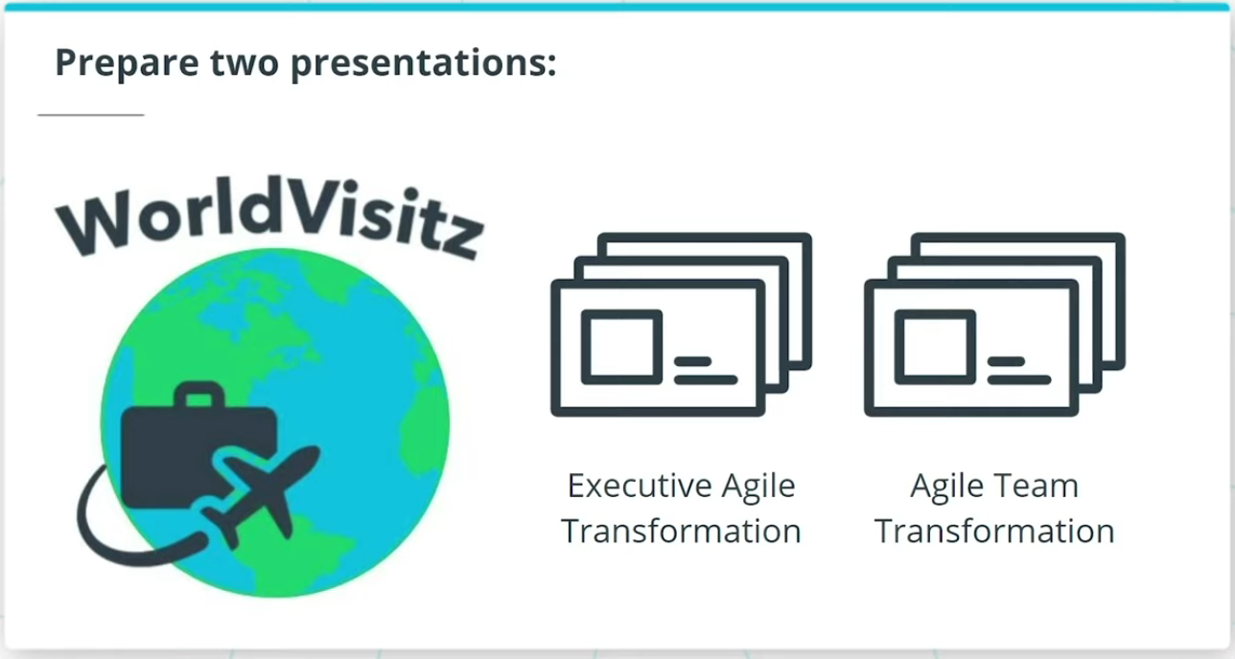

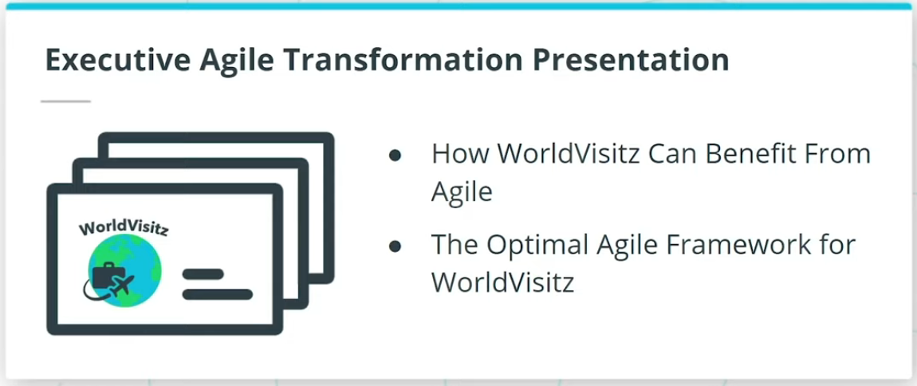

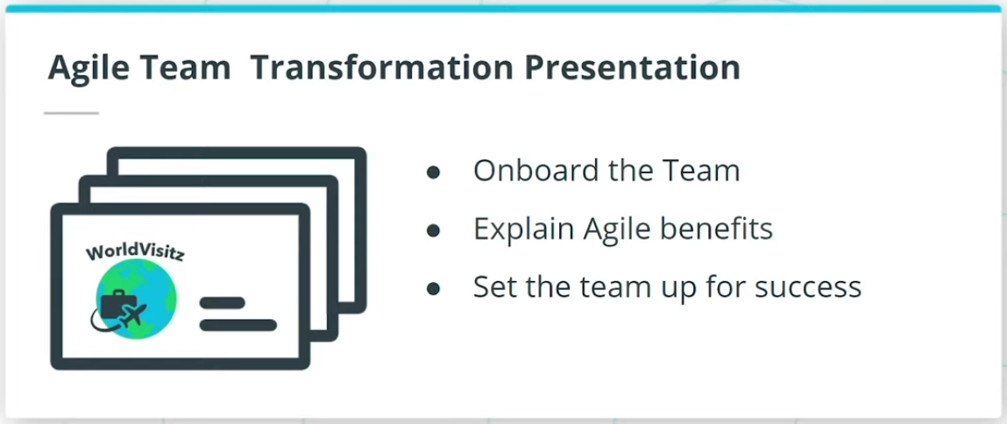

### **WorldVisitz Project Details**

In this project:

* You will apply the skills you will have acquired in this course to step into a business case as an Agile consultant to help launch their Agile journey.
* Your client WorldVisitz is a Travel agency that is planning to launch a mobile application product.
* WorldVisitz executives have hired you to define an Agile delivery solution to transform their current traditional product development processes.

Based on the details that will be provided, you will prepare two presentations.

### **Executive Presentation**

In the Executive Agile Transformation presentation you will discuss:

* How WorldVisitz Can Benefit From Agile.
* You will also explain to the executives which Agile Framework is best for WorldVisitz's needs.

### **Agile Team Presentation**

Your goal in the Agile Team Transformation presentation is to:

* Onboard the team.
* Explain how WorldVisitz Can Benefit From Agile.
* Set up the team for success including assigning team members to roles and establishing the ceremony structure for the framework you have recommended.

After this project, you will be confidently prepared to embark on your journey as an Agilist!

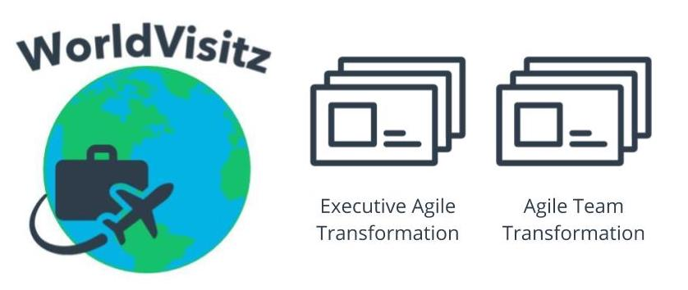

Agile Transformation Project: WorldVisitz Mobile Application

# Let's Go!

## We're Ready To Get Started!

We have briefly looked at the history of Agile and its ability to help teams in all industries steer confidently towards achieving remarkable goals with a business focus.

Get ready to treat yourself to both a **practical** and **intellectual** Agile feast this course has to offer. It will be worth it!